LOT  077777 | P142036-R6-1-0  14X20X36 R6 PLNM EC/RAW  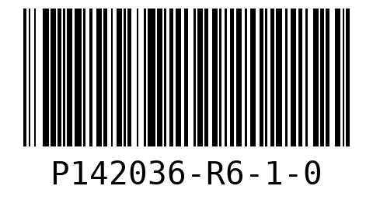  WO 01  LOT 077777  QTY 25
P162036-R6-1-0
16X20X36 R6 PLENUM END CAP/RAW
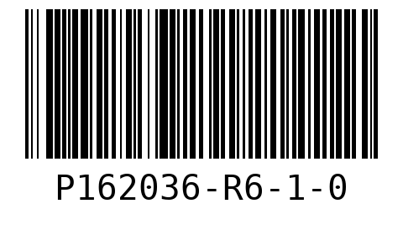
WO 02
LOT 077777
QTY 30

SHEET  1 | P142036-R6-1-0  14X20X36 R6 PLNM EC/RAW  WO 01  LOT 077777
P142036-R6-1-0  14X20X36 R6 PLNM EC/RAW  WO 01  LOT 077777 | P142036-R6-1-0  14X20X36 R6 PLNM EC/RAW  WO 01  LOT 077777
P142036-R6-1-0  14X20X36 R6 PLNM EC/RAW  WO 01  LOT 077777 | P142036-R6-1-0  14X20X36 R6 PLNM EC/RAW  WO 01  LOT 077777

P162036-R6-1-0  16X20X36 R6 PLENUM END CAP/RAW  WO 02  LOT 077777 | P162036-R6-1-0  16X20X36 R6 PLENUM END CAP/RAW  WO 02  LOT 077777
P162036-R6-1-0  16X20X36 R6 PLENUM END CAP/RAW  WO 02  LOT 077777 | P162036-R6-1-0  16X20X36 R6 PLENUM END CAP/RAW  WO 02  LOT 077777
P162036-R6-1-0  16X20X36 R6 PLENUM END CAP/RAW  WO 02  LOT 077777 | P162036-R6-1-0  16X20X36 R6 PLENUM END CAP/RAW  WO 02  LOT 077777

P162036-R6-1-0  16X20X36 R6 PLENUM END CAP/RAW  WO 02  LOT 077777 | P162036-R6-1-0  16X20X36 R6 PLENUM END CAP/RAW  WO 02  LOT 077777
SHEET  2 | P142036-R6-1-0  14X20X36 R6 PLNM EC/RAW  WO 01  LOT 077777
P142036-R6-1-0  14X20X36 R6 PLNM EC/RAW  WO 01  LOT 077777 | P142036-R6-1-0  14X20X36 R6 PLNM EC/RAW  WO 01  LOT 077777

P142036-R6-1-0  14X20X36 R6 PLNM EC/RAW  WO 01  LOT 077777 | P142036-R6-1-0  14X20X36 R6 PLNM EC/RAW  WO 01  LOT 077777
P142036-R6-1-0  14X20X36 R6 PLNM EC/RAW  WO 01  LOT 077777 | P142036-R6-1-0  14X20X36 R6 PLNM EC/RAW  WO 01  LOT 077777
P142036-R6-1-0  14X20X36 R6 PLNM EC/RAW  WO 01  LOT 077777 | P142036-R6-1-0  14X20X36 R6 PLNM EC/RAW  WO 01  LOT 077777

P162036-R6-1-0  16X20X36 R6 PLENUM END CAP/RAW  WO 02  LOT 077777 | P162036-R6-1-0  16X20X36 R6 PLENUM END CAP/RAW  WO 02  LOT 077777
P162036-R6-1-0  16X20X36 R6 PLENUM END CAP/RAW  WO 02  LOT 077777 | P162036-R6-1-0  16X20X36 R6 PLENUM END CAP/RAW  WO 02  LOT 077777
P162036-R6-1-0  16X20X36 R6 PLENUM END CAP/RAW  WO 02  LOT 077777 | P162036-R6-1-0  16X20X36 R6 PLENUM END CAP/RAW  WO 02  LOT 077777

P162036-R6-1-0  16X20X36 R6 PLENUM END CAP/RAW  WO 02  LOT 077777 | P162036-R6-1-0  16X20X36 R6 PLENUM END CAP/RAW  WO 02  LOT 077777
SHEET  3 | P142036-R6-1-0  14X20X36 R6 PLNM EC/RAW  WO 01  LOT 077777
P142036-R6-1-0  14X20X36 R6 PLNM EC/RAW  WO 01  LOT 077777 | P142036-R6-1-0  14X20X36 R6 PLNM EC/RAW  WO 01  LOT 077777

P142036-R6-1-0  14X20X36 R6 PLNM EC/RAW  WO 01  LOT 077777 | P142036-R6-1-0  14X20X36 R6 PLNM EC/RAW  WO 01  LOT 077777
P162036-R6-1-0  16X20X36 R6 PLENUM END CAP/RAW  WO 02  LOT 077777 | P162036-R6-1-0  16X20X36 R6 PLENUM END CAP/RAW  WO 02  LOT 077777
P162036-R6-1-0  16X20X36 R6 PLENUM END CAP/RAW  WO 02  LOT 077777 | P162036-R6-1-0  16X20X36 R6 PLENUM END CAP/RAW  WO 02  LOT 077777

P162036-R6-1-0  16X20X36 R6 PLENUM END CAP/RAW  WO 02  LOT 077777 | P162036-R6-1-0  16X20X36 R6 PLENUM END CAP/RAW  WO 02  LOT 077777
P162036-R6-1-0  16X20X36 R6 PLENUM END CAP/RAW  WO 02  LOT 077777 | P162036-R6-1-0  16X20X36 R6 PLENUM END CAP/RAW  WO 02  LOT 077777
SHEET  4 | P142036-R6-1-0  14X20X36 R6 PLNM EC/RAW  WO 01  LOT 077777

P142036-R6-1-0  14X20X36 R6 PLNM EC/RAW  WO 01  LOT 077777 | P142036-R6-1-0  14X20X36 R6 PLNM EC/RAW  WO 01  LOT 077777
P142036-R6-1-0  14X20X36 R6 PLNM EC/RAW  WO 01  LOT 077777 | P142036-R6-1-0  14X20X36 R6 PLNM EC/RAW  WO 01  LOT 077777
P142036-R6-1-0  14X20X36 R6 PLNM EC/RAW  WO 01  LOT 077777 | P162036-R6-1-0  16X20X36 R6 PLENUM END CAP/RAW  WO 02  LOT 077777

P162036-R6-1-0  16X20X36 R6 PLENUM END CAP/RAW  WO 02  LOT 077777 | P162036-R6-1-0  16X20X36 R6 PLENUM END CAP/RAW  WO 02  LOT 077777
P162036-R6-1-0  16X20X36 R6 PLENUM END CAP/RAW  WO 02  LOT 077777 | P162036-R6-1-0  16X20X36 R6 PLENUM END CAP/RAW  WO 02  LOT 077777
P162036-R6-1-0
16X20X36 R6 PLENUM END CAP/RAW
WO 02
LOT 077777

